Materials Knowledge Organiser

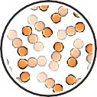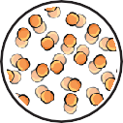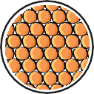 Liquids Gases
Solids

stay in one place keep their shape do not flow
always take up the same amount of space do not spread out
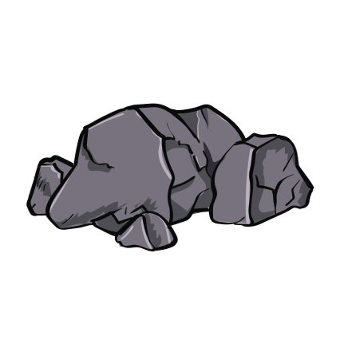can be cut or shaped
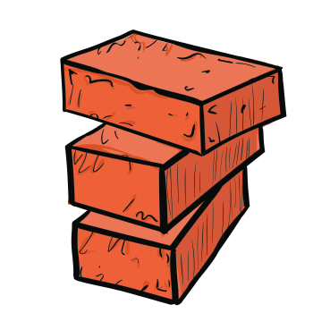
can flow or be poured not easy to hold
change their shape to fit the container they are in
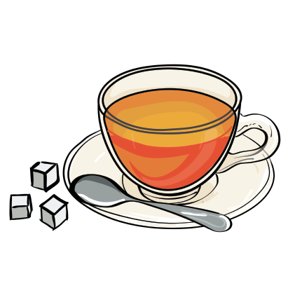take up the same amount of space volume stays the same
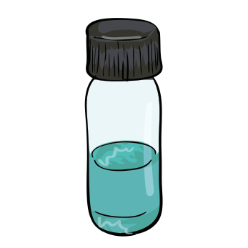
often invisible
do not keep shape
do not take up the same amount of space can change shape and volume
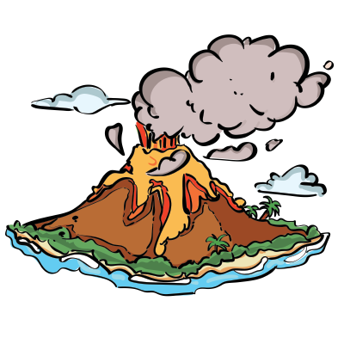can be squashed

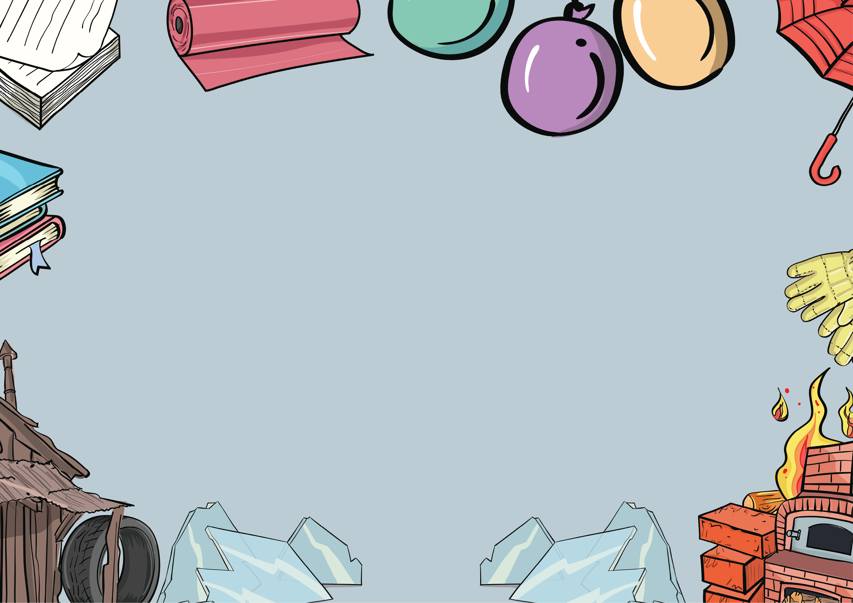

States of matter can change when they
are heated or cooled.
Words to describe materials:
cool
cool
- hard
- soft
- durable
- flexible
- transparent
- absorbent
- waterproof
- magnetic
- translucent
- opaque
gas liquid solid
Different materials are suitable for different jobs because of their qualities and properties.
heat
heat
For example, rubber is a good material for tyres because it is durable.


www.grammarsaurus.co.uk

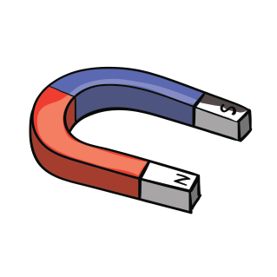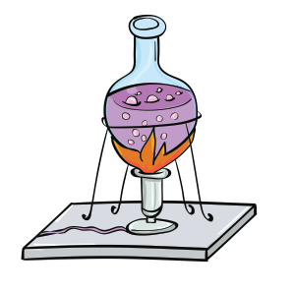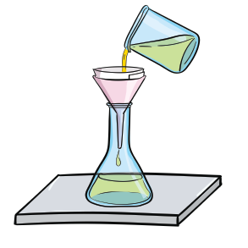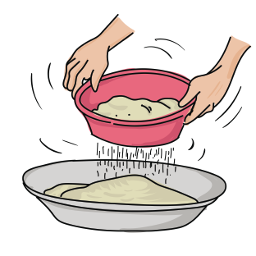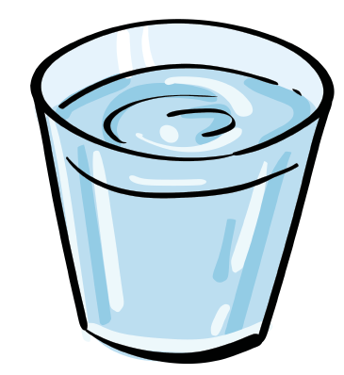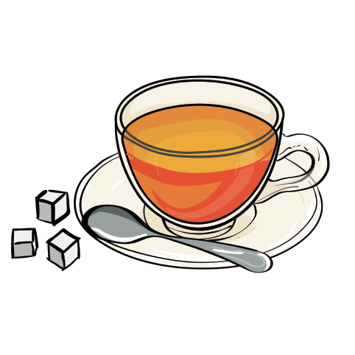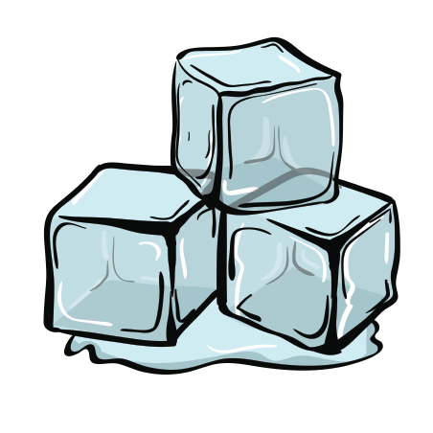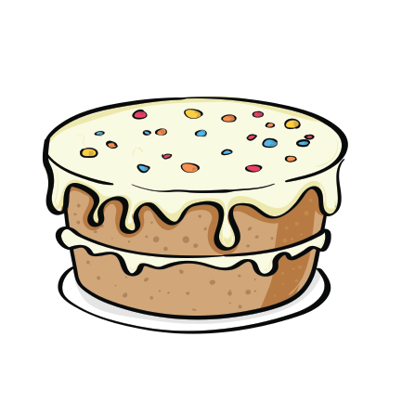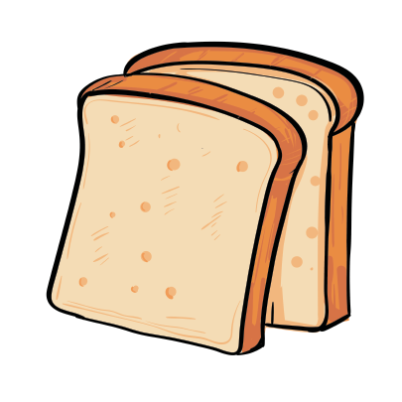

evaporation – used for separating a soluble solid and a liquid
sieving – used for separating two solids
magnets – used for separating magnetic and non-magnetic materials
filtration – used for separating a liquid and a solid
Separating materials

A solution is made when a material dissolves in a liquid. Sugar and water
are soluble materials. An insoluble material does not dissolve in liquid, such
as sand. Materials in a solution can be separated by evaporation.
Solutions
www.grammarsaurus.co.uk
Reversible changes
Reversible changes are when you can get the original
materials back. Materials can be separated in different ways.
making ice cubes
mixing sugar in tea
Irreversible changes
Irreversible changes are when you cannot get the original materials back again. Heating and chemical reactions can both
cause irreversible changes.
making toast
baking a cake

