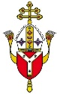

ST IGNATIUS CATHOLIC PRIMARY SCHOOL EXCELLENCE • UNITY • SERVICE

Year Three Optional Home Learning: Spring 1

OPTIONAL HOME LEARNING: The home learning tasks set out in the grid below are OPTIONAL. They are drawn from the topics and areas of study each half term. These tasks are designed to support and extend learning in these areas.
Please send any home learning that has been completed into school. With the practical tasks, if you would like to add a photo or a few sentences in your Home Learning Book to let us know how you found these tasks, please do. Alternatively, you may like to bring the activity/task into school to show your teacher and class. Other tasks can be completed in your Home Learning Book. You can complete these any time within the half term if you wish to do them!

(Tasks completed in the books will be looked at by your teacher on a Monday when the Home Learning books are due to be in school. Your Home Learning Books will be returned to you every Wednesday.)

Science  This term will be learning about magnets and forces.  Make a list of all the objects in your house that are magnetic. What types of metals are magnetic in your house?   | Spanish  Learn all the names for fruits and vegetables in Spanish.  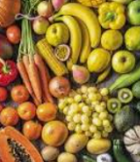 | DT  To practise using a needle and thread at  home. This term will be learning a range  of different stitches. Try practising at  the cross stitch so you will find it easier.
Topic  Our Geography topic this term is Rivers. Visit the River Thames. Make a tally of the wildlife at the river.  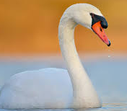 | RE  Make an Easter garden for Lent.  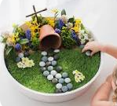 | Art  Choose a station of the cross and  Create a piece of artwork based on  A station. You could use pencil,  Watercolour or charcoal.  

